Cadorna, Joeffrey 6/25/2026
BSCS – 2 (CBM)
- Basic PHP Concept
Act 1
Source Code
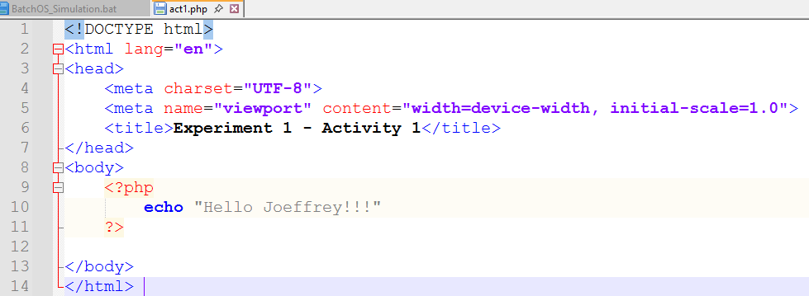
Browser Output
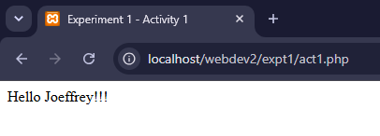

Act 2
Source Code
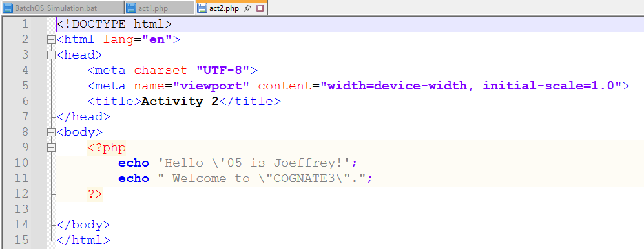

Browser Output
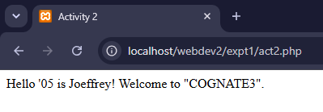

Act3
Source Code
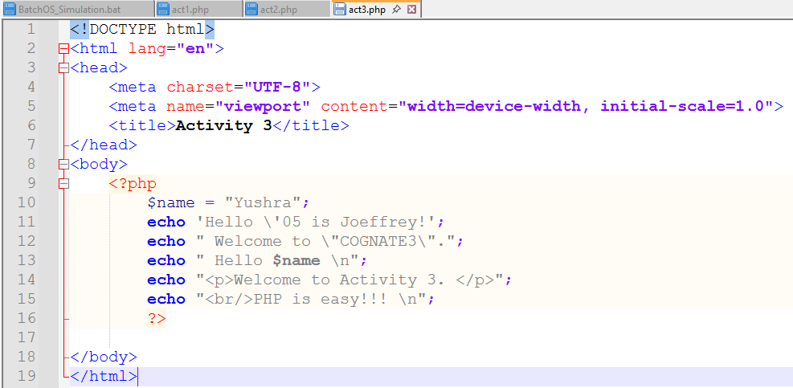
Browser Output
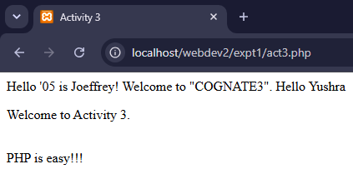

Act4
Source Code
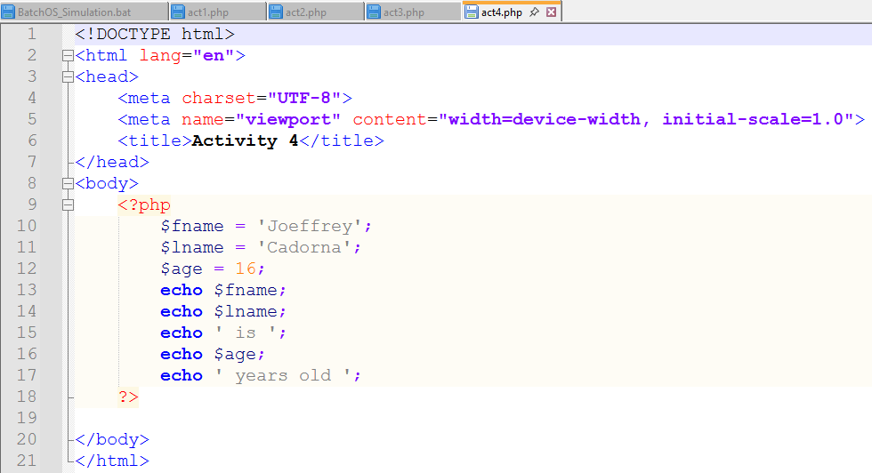
Browser Output
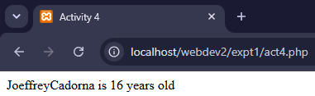

Act5
Source code
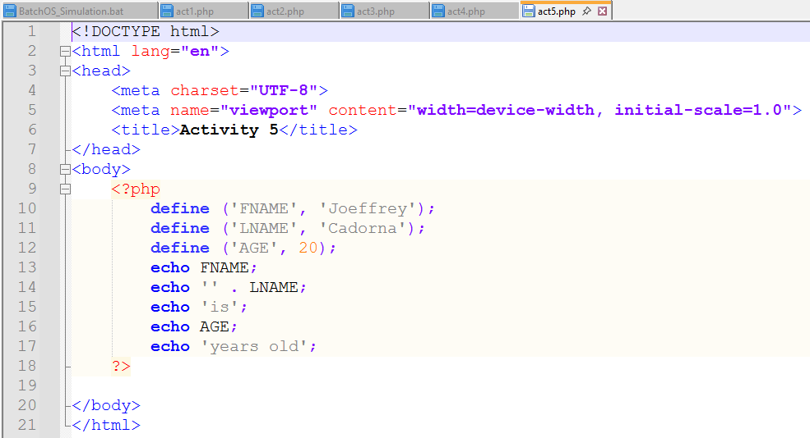
Browser Output
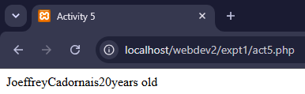

Act6
Source Code
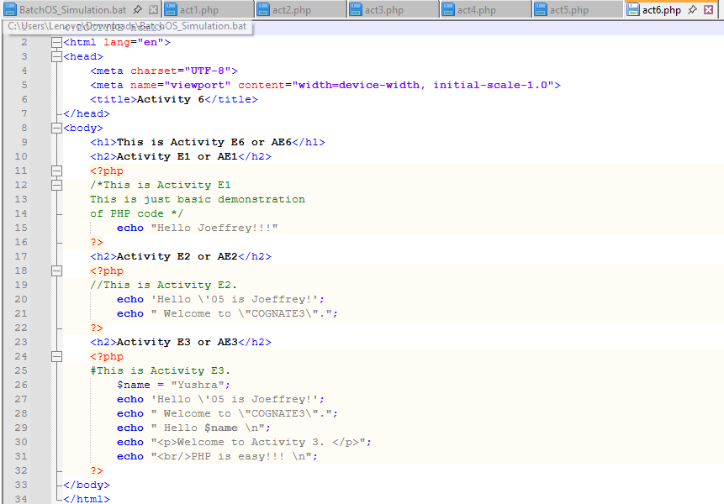
Browser Output
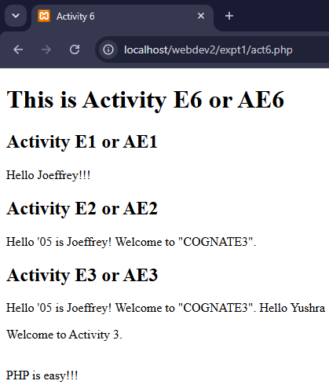

- Answer the following question:
1. Double Quote (") vs. Single Quote (')
Double Quotes: PHP will parse the string for variables and special escape sequences (like \n). For example, "Hello $name" will display the value of the variable.
Single Quotes: PHP treats the string as a literal. It does not parse variables; it will display exactly what is typed (e.g., 'Hello $name' displays the literal characters "$name").
2. PHP Keywords Case Sensitivity
FALSE, because in PHP, keywords (ex. if, else, while, echo), functions, and classes are not case-sensitive. But is/are, variable names case-sensitive
3. String Concatenation
The dot operator (.) is used to concatenate strings, for example; Syntax: $string1 . $string2
4. Purposes of Comments
The purpose of comments because it is used to/for: First, Disable code execution, that temporarily "comment out" lines during testing/debugging. Second, Documentation, which provide metadata like authors, dates, or of alike. And lastly Organize code, by creating visual breaks between large sections of logic.
5. PHP Data Types
String: A sequence of characters (ex. "Hello").
Integer: Non-decimal whole numbers (ex. 42).
Float (Double): Numbers with a decimal point (ex. 10.5).
Boolean: Represents two possible states: true or false.
Array: Stores multiple values in a single variable.
Object: Instances of user-defined classes.
NULL: A variable that has no value assigned.
6. PHP Keywords
Control Structures: if, else, elseif, switch, case, default.
Loops: while, do, for, foreach, break, continue.
Functions/Classes: function, class, public, private, protected, static, new, return.
Others: echo, print, include, require, and empty.

